**Homework 9.1**

1. Euclid’s algorithm is used for finding ___________  
   **a) GCD of two numbers**b) GCD of more than three numbers  
   c) LCM of two numbers  
   d) LCM of more than two numbers
2. The Euclid’s algorithm runs efficiently if the remainder of two numbers is divided by the minimum of two numbers until the remainder is zero.  
   **a) True**  
   b) False

**Homework 9.2**

1. Visualize modulus with clocks : 8 mod 4
2. Visualize modulus with clocks : -5 mod 3

**Homework 9.3**

1. **Chinese Remainder Theorem states that there always exists an x that satisfies given congruences:**

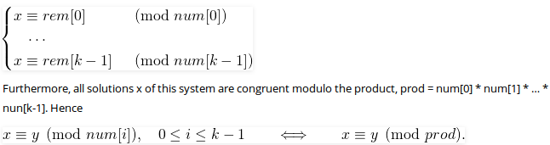

1. **True**
2. **False**
3. The Chinese remainder theorem states that if one knows the remainders of the Euclidean division of an integer n by several integers, then one can determine uniquely the remainder of the division of n by the product of these integers, under the condition that the divisors are pairwise coprime.
4. **True**
5. False

**Homework 9.4**

1. Rabin Karp Algorithm makes use of elementary number theoretic notions.  
   **a) True**  
   b) False
2. What is the worst case running time of Rabin Karp Algorithm?  
   a) Theta(n)  
   b) Theta(n-m)  
   **c) Theta((n-m+1)m)**  
   d) Theta(nlogm)

**Homework 9.5**

1. What is the worst case time complexity of KMP algorithm for pattern searching (m = length of text, n = length of pattern)?  
   a) O(n)  
   b) O(n*m)  
   **c) O(m)**  
   d) O(log n)
2. The KMP matching algorithm uses degenerating property and the basic idea behind KMP’s algorithm is whenever we detect a mismatch (after some matches), we already know some of the characters in the text of the next window. We take advantage of this information to avoid matching the characters.
3. True
4. False

**Homework 9.6**

1. What character shift tables does Boyer-Moore's search algorithm use?
2. good-character shift tables
3. bad-character shift tables
4. next-character shift tables
5. **both good and bad character shift tables**
6. What is the running time of Boyer-Moore's algorithm?
7. **O(mn)**
8. O(m+n)
9. O(log n)
10. O(n)

**Homework 9.7**

1. What is the other name for quick hull problem?  
   **a) convex hull**  
   b) concave hull  
   c) closest pair  
   d) path compression
2. What does the following diagram depict?  
   [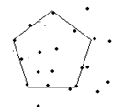](https://www.sanfoundry.com/wp-content/uploads/2018/07/quickhull-questions-answers-q6.png)  
   a) closest pair  
   **b) convex hull**  
   c) concave hull  
   d) path compression